

Public Equities: Sectoral Exposure

Portfolio Overview

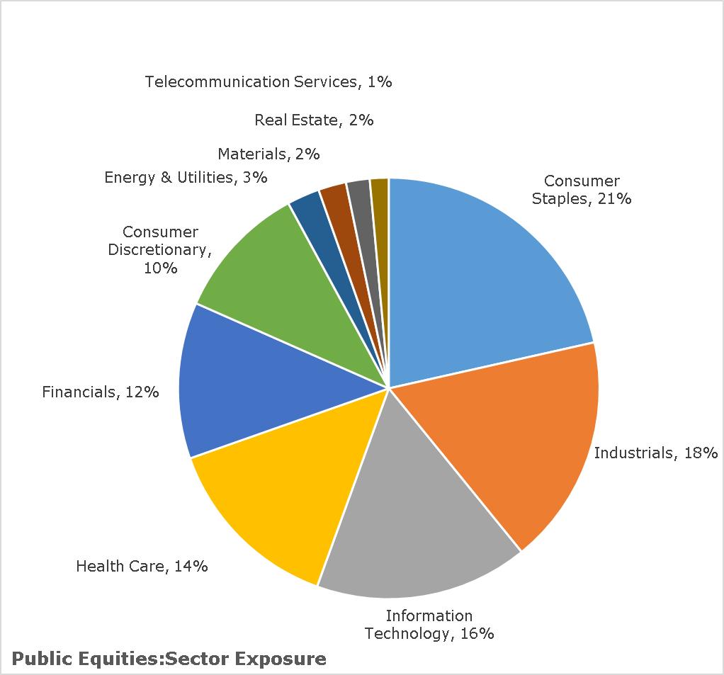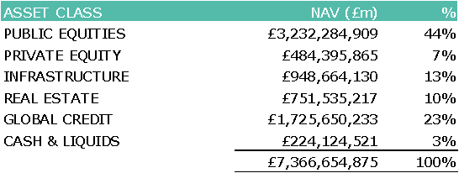

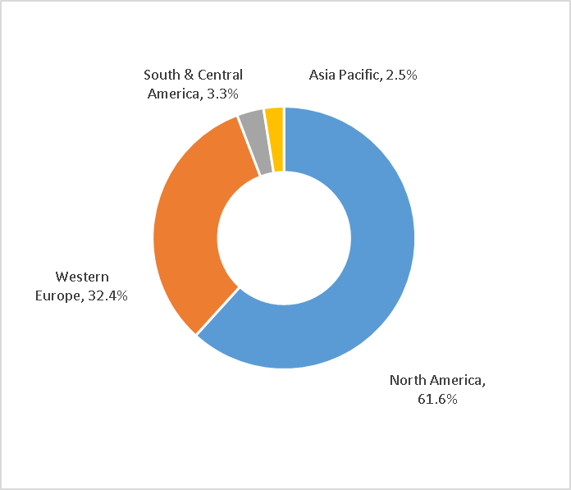

Public Equities: Geographical Exposure

Public Equities: Top 10 Holdings (LPP Global Equities Fund)



Public Equities: Shareholder Voting



Voting by Proposal Type

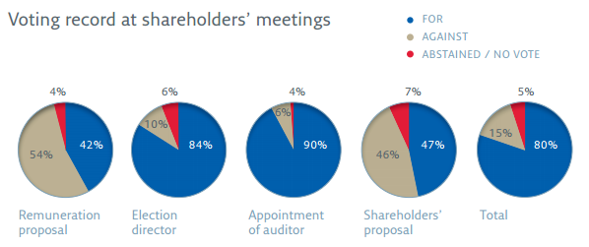

Full details of shareholder voting in the period are available from the LPP website:

**<https://www.localpensionspartnership.org.uk/what-we-do/investment-management>**

It is the intention is to add summary content on other asset classes than listed equities once sufficient look-through is available to enable bottom-up details to be aggregated into data on headline sectoral exposure. This is a work in progress currently.

Spotlight on Sustainability

Guild Investments Ltd

Asset Class: Infrastructure

Investment Vehicle: LPP I Global Infrastructure Fund (GIF)

Asset Type: Onshore windfarms in Portugal

Value of LCPF Investment: £xm

Brief Commentary:

Through it’s investment in the LPP I Global Infrastructure Fund, LCPF is providing direct funding for clean and renewable energy generation in Portugal. Under a long-term partnership with EDF Energies Nouvelles, LPP I GIF owns a significant minority equity stake in a portfolio of eight onshore wind farms in Northern Portugal. With a gross capacity of around 500MW this ranks among the top five wind platforms in the country. Portugal is an attractive location for wind farm installations, having a windy terrain, a stable feed-in-tariff regime and the support of local communities.

The investment primarily targets reliable long-term income yields which match the long-term liabilities of client pension funds but is simultaneously assisting the transition to renewable forms of energy essential for achieving global emissions reduction targets under the Paris Agreement and progress against United Nations Sustainable Development Goal 7 which aims to ensure access to affordable, reliable, sustainable and modern energy for all by 2030.

A sustainability section has been added to address the Responsible Investment Working Group’s request (on behalf of the PFC) for better information on what the fund is invested in and how it is contributing to wider social benefits. The suggested section would focus on one specific investment (outside listed equities) each quarter to offer a bite-sized summary of an investment with clear sustainability characteristics.

